Numerical Investigation of the Performance and Emission Characteristics of a Spark Ignition Engine Operating with Hydrogen

Temilola Taiwo Olugasa¹, Nabil Olanrewaju Ibrahim-Oladosu¹, Victor Eromosele Okoruwa^{2,} Nosa Idusuyi¹
¹Department of Mechanical Engineering, Faculty of Technology, University of Ibadan
²Department of Automotive Engineering, Faculty of Technology, University of Ibadan

ABSTRACT
This study investigates the performance and emission characteristics of a spark ignition engine operating with hydrogen as a supplementary fuel. The aim is to identify optimal operating conditions and design modifications that enhance engine efficiency while minimizing harmful emissions, including nitrogen oxides (NOx). A numerical simulation approach was employed to model the engine under varying operating conditions and geometric configurations. The results demonstrate that the addition of hydrogen to conventional gasoline significantly improves engine efficiency and reduces emissions such as carbon monoxide (CO) and unburned hydrocarbons (HC). However, hydrogen combustion also poses a challenge due to its tendency to increase NOx emissions, which this study addresses by exploring strategies to mitigate this effect. These findings suggest that a dual-fuel system combining hydrogen and gasoline presents a promising solution for improving engine performance and reducing environmental impact. This study highlights the potential of hydrogen as a sustainable alternative fuel for spark ignition engines, while emphasizing the need to address NOx emissions to fully realize its benefits in preserving the environment.
Keywords: Hydrogen, Performance, Alternative fuel, Spark ignition engine, Emissions

1.0 Introduction
The world is dealing with serious environmental problems like climate change and air pollution. One of the main reasons for these problems is the use of engines that run on fossil fuels, like gasoline. These engines, especially spark ignition engines, release harmful gases such as carbon monoxide (CO), unburned hydrocarbons (HC), and nitrogen oxides (NOx). These gases contribute to global warming and can cause respiratory problems in people. Cleaner energy sources are therefore being explored, to replace fossil fuels. Hydrogen stands out as one of the best alternatives. It contains about three times more energy per weight than gasoline and burns very cleanly, producing mainly water vapour. This makes it much better for the environment compared to gasoline. The main advantage of hydrogen over fossil fuels is that it does not produce any carbon-based pollutants. However, there is still a problem with using hydrogen in engines. When hydrogen burns at high temperatures, it creates nitrogen oxides (NOx), which contribute to acid rain and respiratory problems. Hence, while hydrogen is a great fuel, it is necessary to find ways to reduce NOx emissions when using it.
Recent technology has made it possible for researchers to study how adding hydrogen to gasoline affects engine performance. By using computer simulations, we can understand what happens when different amounts of hydrogen are mixed with gasoline. This study uses these simulation tools to examine how a spark ignition engine performs when running on a mixture of hydrogen and gasoline. The goal is to find the best combination and engine settings that improve efficiency while reducing harmful emissions, especially NOx. The results could help design cleaner, more efficient engines that are better for our environment and health.
Hydrogen is a clean fuel that can help reduce harmful emissions from engines. However, when hydrogen burns, it creates very high temperatures, which leads to the production of nitrogen oxides (NOx). NOx is a harmful gas that causes air pollution and health problems. While researchers have studied hydrogen as a fuel, there is still a need to find the best ways to use hydrogen in engines to reduce NOx emissions without losing performance. This study aims to solve this problem by using computer simulations to test different engine conditions. The goal is to find the best ways to use hydrogen to make engines cleaner and more efficient.

2.0 Literature Review
Sustainable alternatives are being searched for because fossil fuels have ecological effects despite the high energy demand. Internal Combustion Engines (ICEs) emit several pollutants, like carbon monoxide, hydrocarbons, and nitrogen oxides, so they substantially contribute to global greenhouse gas emissions. These emissions cause climate change and air pollution which cause respiratory diseases. Alternative fuel sources, such as biofuels, electricity, and hydrogen, have been thoroughly explored, to lessen the harm that ICEs are causing. Hydrogen, along with its exceptionally clean combustion properties coupled with a remarkably high energy content, represents a truly promising candidate among these.
Hydrogen truly is the simplest element. It is also the most overwhelmingly abundant element in the universe, consisting of just one proton and one electron. As a gas, it has absolutely no colour or smell and it always catches fire very easily. Hydrogen is often found in molecules such as hydrocarbons in addition to water (H₂O). Therefore, using it as fuel necessitates many different extraction techniques. Due to its high energy content, it is a desirable choice for many energy applications (Stępień, 2021, Podsadni & Czerwiński, 2022).

2.1 Methods of Production
Hydrogen can be produced through different methods. These methods include steam methane reforming (SMR), electrolysis, biomass gasification, and thermochemical water splitting.
The most common method is SMR, which extracts hydrogen from natural gas but produces carbon emissions unless coupled with Carbon Capture and Storage (CCS). This process results in "blue hydrogen" if carbon emissions are managed and "grey hydrogen" if they are not (Purayil et al., 2023).
CH₄ + 2H₂O_{(g)} → CO_{2(g)} + 4H_{2(g)}
Electrolysis of water using renewable energy sources produces "green hydrogen," the cleanest and most sustainable option. It can be entirely carbon-free if all renewable energy sources power it (Purayil et al., 2023).
2H₂O_{(l)} → 2H_{2(g)} + O_{2(g)}
Organic materials can be converted through partial oxidation in biomass gasification, resulting in carbon dioxide, carbon monoxide, and hydrogen. Thermochemical water splitting utilises high-temperature heat (from sources like nuclear or solar energy) to split water molecules into hydrogen and oxygen. The scalability and sustainability of hydrogen production are key challenges that need to be addressed to make hydrogen a viable mainstream fuel (Podsadni & Czerwiński, 2022).

2.2 Hydrogen as an alternative fuel
Hydrogen's suitability as a fuel for SI engines has been explored in many studies. Karim (2003) discusses the fundamental properties of hydrogen; its high diffusivity, wide flammability range, and low ignition energy. These properties contribute to efficient combustion in SI engines.
Unlike conventional fuels, hydrogen combustion does not produce carbon dioxide (CO₂), making it an environmentally friendly option for reducing greenhouse gas emissions. Additionally, hydrogen has a high Research Octane Number (RON), which improves its anti-knock properties, leading to higher compression ratios and improved thermal efficiency in ICEs. Hydrogen’s rapid flame propagation speed ensures efficient combustion, reducing fuel consumption and increasing power output under certain conditions (Purayil et al., 2023). Hydrogen is a better choice for lowering emissions than regular fuels. Hydrogen's elevated combustion temperature can unfortunately result in a greater degree of NOx formation. This happens in all cases. This issue can be overcome through careful engine design and operation (Karim, 2003).
Likewise, Niculae et al. (2012) investigated the practical aspects of using hydrogen in SI engines. Hydrogen combusts completely within an ICE and yields water vapour as its most important by-product. It reduces pollutant emissions like carbon dioxide (CO₂). Unfortunately, the risk of backfire along with pre-ignition, is greater than with conventional fuels. The study emphasises the need for optimising engine parameters. These parameters incorporate the air-fuel ratio in addition to ignition timing.These problems must be lessened to get the optimal from burning hydrogen. These depend on solving the above-enumerated problems. Das (2002) additionally stressed the need for multiple advanced combustion strategies to precisely control NOx formation in all hydrogen-fuelled engines. These studies show that optimizing hydrogen combustion is important for balancing performance and emissions.

2.3 Performance and Emission Characteristics
Engines powered by hydrogen have demonstrated better performance when compared to traditional gasoline engines. Rahman et al. (2009) stated that hydrogen combustion leads to increased thermal efficiency. This is because of the quick combustion process and hydrogen's higher energy content. Still, reaching the optimal performance levels requires precise changing of the engine's operational settings. These include the compression ratio, air-fuel ratio, and ignition timing. Hydrogen–gasoline dual-fuel engines exhibit notable improvements in thermal efficiency, especially at low and partial loads. The combination of hydrogen with gasoline enhances combustion efficiency due to hydrogen’s higher flame speed and wider flammability limits, leading to more complete combustion and lower unburned hydrocarbon (HC) emissions. However, the performance deteriorates at high loads due to increased combustion instability (Purayil et al., 2023).
Characteristics of emissions are also a crucial factor for engines powered by hydrogen. Using hydrogen has the major benefit of removing CO₂ emissions. Even so, the elevated combustion temperatures for hydrogen may result in higher NOx emissions. This is still a damaging pollutant (Rahman et al., 2009). Numerical simulations are important in creating plans to lower NOx emissions. Strategies like exhaust gas recirculation (EGR) and lean-burn combustion methods are employed.

2.4 Hydrogen-Gasoline Dual-Fuel Systems
Issues with pure hydrogen engine usage can be mitigated through dual-fuel systems to burn a combination of hydrogen and conventional fuels (e.g., gasoline). By combining hydrogen and gasoline, researchers hope to capture all the benefits of both fuels while mitigating the drawbacks. Gasoline provides energy density, which helps the combustion temperature to lower NOx creation, and the added hydrogen then enhances combustion efficiency to deliver lower carbon-based emissions. Hydrogen gas-gasoline dual-fuel system performance and emission characteristics have also been studied. It was discovered that the addition of hydrogen increased engine performance and decreased CO and HC emissions, greater hydrogen ratios also caused an increase in NOx emissions. Similarly, Akif et al. (2012) investigated how the addition of hydrogen affected engine performance and emissions using numerical models. It was observed that engine performance may be enhanced while NOx emissions were reduced by adjusting the hydrogen-to-gasoline ratio.
Purayil et al. (2023) worked on the effects of hydrogen addition to a SI dual-fuel engine. It was revealed that at 8 litres per minute (LPM) of hydrogen flow, the in-cylinder pressure increased by 52.04%, leading to a 95.53% rise in engine torque. Additionally, the Brake Thermal Efficiency (BTE) saw a 25% improvement, and Brake Specific Energy Consumption (BSEC) was reduced by 92.27%. After getting the above results on the performance, it was also discovered by Purayil et al. (2023) that hydrogen enrichment leads to mixed effects on emissions. On the positive side, carbon monoxide (CO) emissions decreased at all hydrogen levels, primarily due to hydrogen’s lack of carbon content and its ability to facilitate complete combustion. However, nitrogen oxide (NOx) and carbon dioxide (CO₂) emissions increased with hydrogen addition due to the higher combustion temperature. Purayil et al. (2023) analysed the performance of hydrogen–gasoline dual-fuel engines and found that EGR can reduce NOx emissions by 77.8%.

2.5 Numerical Investigations of Engine Performance and Emission Characteristics
Hydrogen is a costly and complicated fuel, which makes numerical studies critical in the research of hydrogen engines. Simulation tools allow researchers to model and predict engine performance and emissions under various conditions without expensive experimental setups. This method is especially important for studying the specific combustion behaviour and optimising the engine design for operating with properties that are specific to hydrogen, for example, high flame speed and propensity for knocking (Podsadni & Czerwiński, 2022).
Studies on hydrogen-fuelled SI engines have provided insight into their performance and emissions. Xu and Bai (2023) conducted a study on an ammonia/hydrogen/n-heptane engine under RCCI (Reactivity Controlled Compression Ignition) conditions. It was discovered that hydrogen addition may enhance combustion efficiency and lower carbon emissions. Results showed that hydrogen can be integrated to improve performance while maintaining low emissions (Nguyen et al., 2023). Nguyen et al. (2023) further explored the impact of hydrogen on SI engine performance by analysing different compression ratios. The study showed that at higher compression ratios, hydrogen can strongly improve thermal efficiency and reduce specific fuel consumption. The study also noted a trade-off between NOx emissions and engine performance. This highlights the importance of finding an optimal balance.
Hamada et al. (2016) performed a numerical study for in-cylinder flow characteristics of hydrogen-fuelled SI Engines. By also showing how hydrogen’s high diffusivity facilitates the mixing of fuel and air, their study led to an understanding of fuel-air uniformity. The findings suggested a more stable combustion and less cyclic variation. Combustion uniformity helps in reducing emissions and improving overall engine efficiency. Thus, hydrogen presents a possible alternative for future SI engine designs (Hamada et al., 2016).
While the use of hydrogen as a fuel presents many advantages, several challenges remain. Ciniviz and Kose (2012) discussed the risks of pre-ignition and knock as well as the high emission of NOx. The challenge of high NOx emissions could be mitigated through through proper engine design and treating the emissions after they are released (Stępień, 2021). This requires a close monitoring of engine operating conditions. Another of the challenges that negates the widespread adoption of this fuel is the high cost of its production. As pointed out by Ogden (2018) and Dunn (2002), there is a need to advance hydrogen infrastructure. Such infrastructures should accommodate hydrogen production, storage, and distribution.
Numerical simulations, in particular, can help overcome the technical challenges of hydrogen combustion. Additionally, the use of hybrid systems that combine hydrogen with other fuels or power sources could contribute to the development of more sustainable and efficient energy systems (Stepien (2021) and Wróbel et al. (2022).

3.0 Methodology

3.1 Overview of Numerical Approach
This study employed numerical simulation approach to investigate the performance and emission characteristics of a spark ignition engine operating with a hydrogen-gasoline dual-fuel system. The research design involved the following steps:
- Model Development: Creating a computational model of the spark ignition engine.
- Simulation Execution: Running simulations to analyse engine performance and emissions under different operating conditions and engine configurations.
- Model Validation: The values obtained from the simulation were validated with an existing body of work.
- Data Analysis: Evaluating the results to identify optimal conditions and strategies for emission reduction.
3.2 Model Development
The study used a 0D/1D model of a spark ignition engine based on a real-world engine design. The engine geometry include: dimensions of the combustion chamber, length of the connecting rod, intake/exhaust ports opening and closing angles, and more. The model was developed using the engine specifications indicated in Table 1.
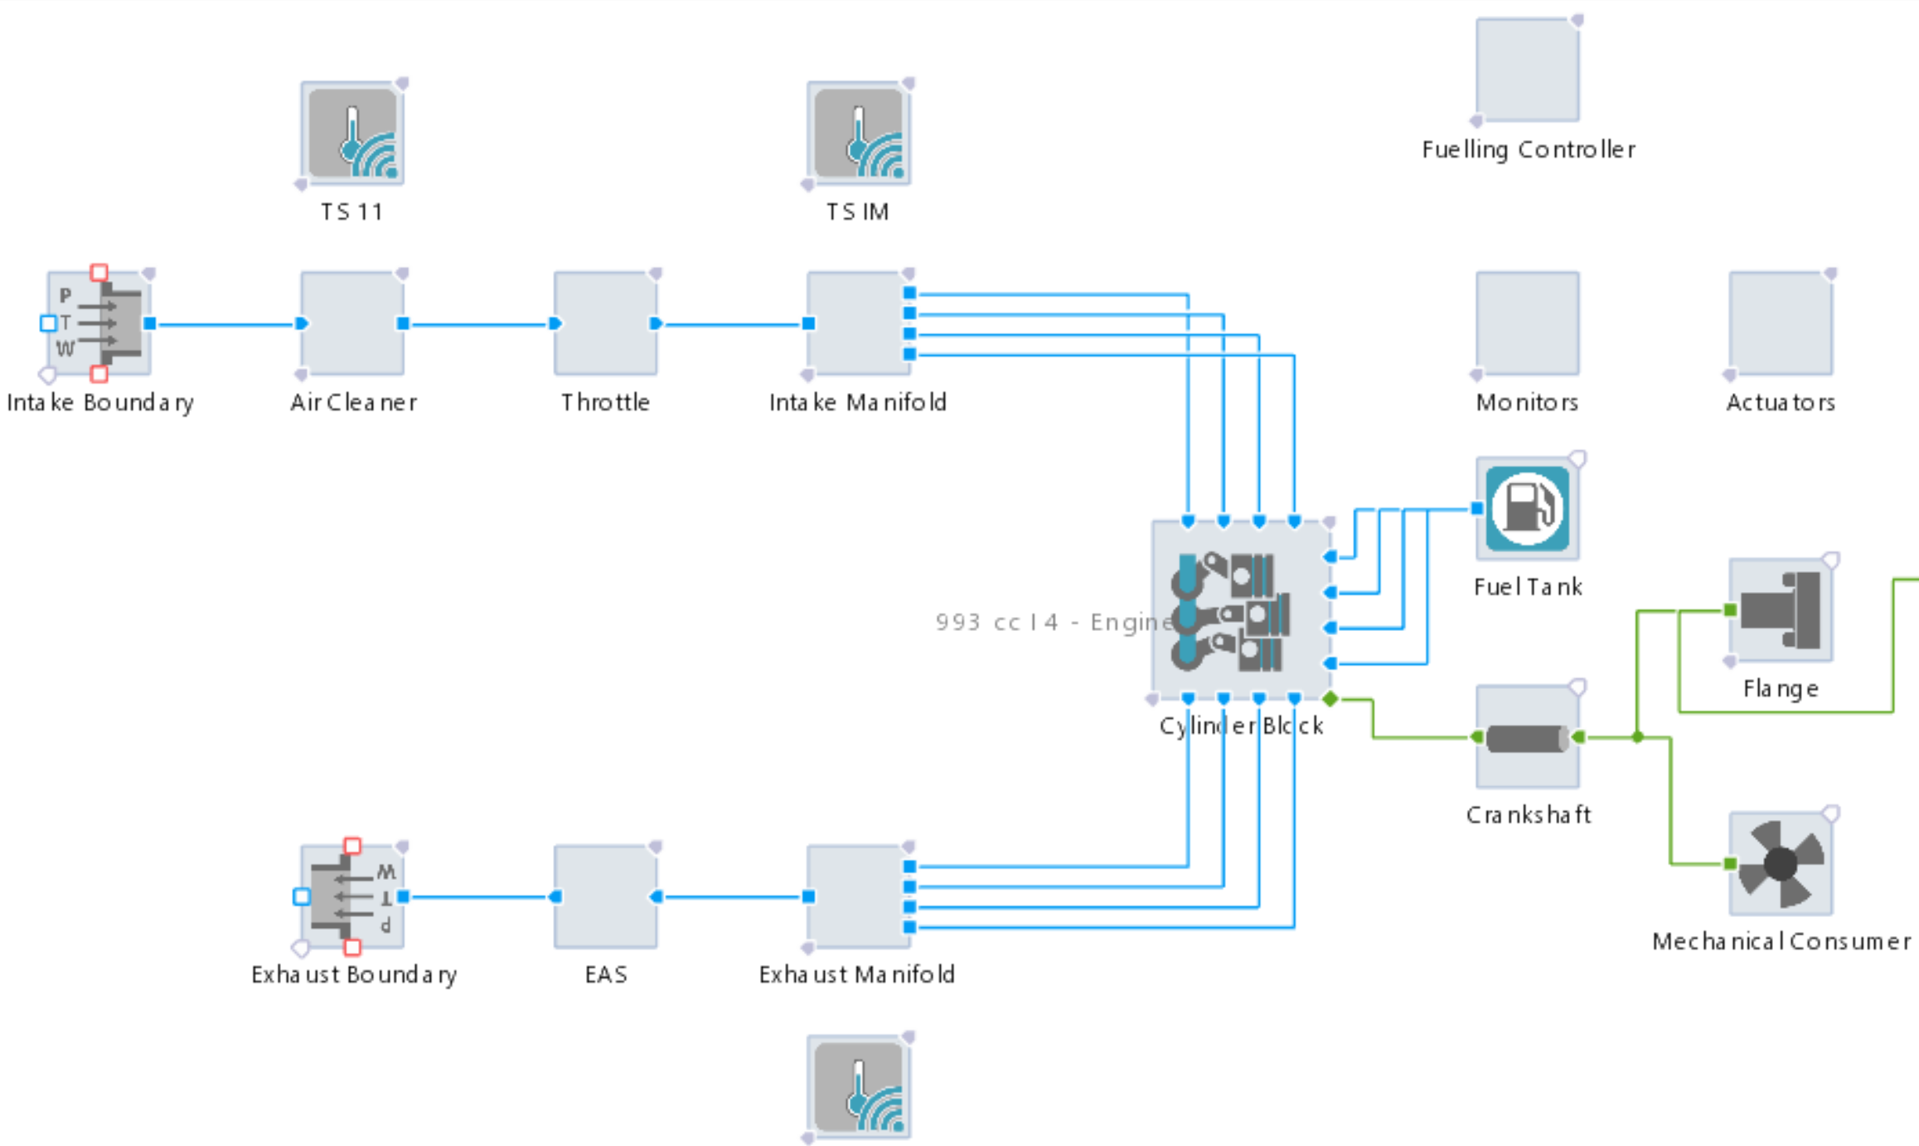
Figure 1: Screenshot of the developed model in AVL

Table 1: Engine Specification
Parameter | Value
Number of Strokes | 4
Cylinder number | 4
Cylinder Bore | 72 mm
Cylinder Stroke | 61mm
Swept Volume | 993 cc
Compression Ratio | 9.4 : 1
Injector | Port Fuel Injector
Connecting Rod Length | 130 mm
Number of Valves | 2 for intake, 2 for exhaust
Inlet Valve Opening | 341
Inlet Valve Closing | 568
Exhaust Valve Opening | 152
Exhaust Valve Closing | 365

3.2.1 Fuel Properties and Mixture Ratios
The study investigated the effects of different hydrogen-to-gasoline ratios on engine performance and emissions. The fuel properties of hydrogen and gasoline were defined based on standard thermodynamic data. These properties are presented in Table 2

Table 2: Characteristics of Hydrogen and Gasoline. Yan et al. (2018), Lapuerta et al. (2014), Log and Moi (2018), Coronado et al. (2012), Zaharin et al. (2018), Bae and Kim (2017)

Parameter | Hydrogen |  | Gasoline
Chemical Formula | H₂ | C₄ – C₁₂
Molar Mass (G/Mol) | 2 | 60 - 170
Energy Density (MJ/kg) | 120 | 44
Density (G/cm³) | 0.0013 (at 15ºC) | 0.748 (at 15ºC)
Laminar Flame Speed (m/s) | 1.85 | 0.37 – 0.43
Autoignition Temperature (^{O}C) | 500 - 585 | 247 - 280
Stoichiometric Air-Fuel Ratio (By Mass) | 34.3:1 | 14.7:1
Lower Heating Value (MJ/kg) | 120 | 44
Diffusivity In Air (cm²/s) | 0.61 | 0.05
Heat Of Evaporation (KJ/kg) | 456 | 346
Latent Heat Of Vaporization (KJ/kg) | 448 | 349
Octane Number | 130 | 87 – 96
Boiling Point (^{O}C) | -252.9 | 25 – 215
Dynamic Viscosity (MPa.s) | 0.009 | 0.37 – 0.44
Minimum Ignition Energy (MJ) | 0.02 | 0.25
Co₂ Emissions | 0 | 73.3
Nox Formation Tendency | High (due to high combustion temperatures) | Moderate (depends on conditions)

3.3 Simulation Tools and Software
The simulations were conducted using Computational Fluid Dynamics (CFD) software, specifically AVL Cruise M. The CFD is widely used in engine research because it provides detailed insights into combustion dynamics, fluid flow, and emission formation. The software solves the governing equations of fluid flow, heat transfer, and chemical reactions to simulate engine behaviour.
The solution methods and algorithms in AVL CRUISE M are designed to handle simple and complex geometries and boundary conditions with high precision. The software employs advanced numerical schemes and discretization methods to ensure accurate and stable solutions, even for challenging scenarios. These methods include finite volume discretization and iterative solvers that converge to reliable results efficiently.

3.3.1 Operating Conditions
The simulations were conducted under various operating conditions to analyse their impact on engine performance and emissions. These conditions include (Table 3):
- Engine Speed: Varied between 1,500 rpm and 4,500 rpm.
- Ignition Timing: Adjusted to optimise combustion efficiency and minimise emissions.
- Air-Fuel Ratio: Tested under stoichiometric and lean conditions. The stochiometric air/fuel ratio for gasoline and hydrogen is 14.7 and 34.3, respectively.
The concentration of hydrogen by volume was varied from 10 to 100% hydrogen by volume to see the effect of different amounts of hydrogen on the performance and emissions of the engine.
The concentrations were varied as follows:
- 10% Hydrogen: Small addition to gasoline
- 20% Hydrogen: Moderate addition
- 40% Hydrogen: Significant addition
- 50% Hydrogen: Equal parts hydrogen and gasoline
- 80% Hydrogen: Dominantly hydrogen with some gasoline
- 100% Hydrogen: Pure hydrogen operation

Table 3: Operating Parameters for the model
Parameter | Range
Engine Speed (rpm) | 1,500 – 4,500 at intervals of 500
Compression Ratio | 9.4 : 1 (Fixed)
H₂ Addition | None
Air-Fuel Ratio | 14.7
Ignition Timing | 3º, 4º, 5º, 6º before top dead centre (bTDC)

Some other important information that was used in the generation of the base model for the study are presented in the table 4:

Table 4: Other Notable Information

Parameter | Value
Combustion Model | Two Zone Vibe
Cylinder Arrangement | Inline
Engine Friction | Shayler, Leong, Murphy - model
Vibe Shape Parameter (M) | 1.95
Vibe Parameter (A) | 5.9
Maximum Valve Lift | 6.6
Cylinder Arrangement | Inline
Charging Type | Naturally Aspirated

Validation of the Base Model
To ensure the accuracy of the simulation results, the model was validated against experimental data from a previous study by Nayak et al. (2017). This model was used to accurately develop an engine model that ran primarily using only gasoline as fuel. The performance parameters were: Indicated Mean Effective Pressure (IMEP) (kPa), Power (kW), Torque (Nm)
and Emissions. These parameters were compared with published results to verify the reliability of the model.

4.0 Results and Discussions
4.1 Overview of Simulation Results
Numerical simulations were performed using the AVL simulation environment to investigate the performance and emission characteristics of a spark-ignition engine operating under hydrogen–gasoline dual-fuel conditions. The study evaluated the influence of hydrogen energy fraction on brake thermal efficiency (BTE), brake-specific energy consumption (BSEC), carbon monoxide (CO), and nitrogen oxides (NOx) emissions.
The simulations were conducted at a constant engine speed of 2500 rpm, compression ratio of 9.4:1, ignition timing of 5° bTDC, and stoichiometric air–fuel ratio (λ = 1.0). The hydrogen fraction in the fuel blend was varied from 0% to 100%.
The results demonstrate that hydrogen enrichment significantly influences combustion behaviour due to hydrogen’s high laminar flame speed, wide flammability limits, low ignition energy, and high diffusivity. These properties improve combustion efficiency and reduce incomplete combustion products, although they also promote elevated in-cylinder temperatures that enhance thermal NOx formation.
Table 4.1 presents the summarized simulation results obtained under varying hydrogen concentrations.
Table 4.1: Summary of performance and emission characteristics under varying hydrogen concentrations
Hydrogen Concentration (%) | BTE (%) | BSEC (MJ/kWh) | CO (%) | NOx (ppm)
0 | 26 | 13.7 | 5.2 | 325
20 | 29 | 12.5 | 3.0 | 600
50 | 31 | 11.0 | 0.9 | 1025
80 | 29.5 | 11.7 | 0.6 | 1400
100 | 28 | 12.5 | 0.4 | 1800
4.2 Effect of Hydrogen Concentration on Brake Thermal Efficiency (BTE)
A gradual improvement in BTE was observed with increasing hydrogen concentration. At low hydrogen fractions, the improvement was relatively modest due to enhanced flame propagation and improved mixture homogeneity. Hydrogen promotes faster and more stable combustion because of its high flame speed and low ignition energy requirement. The combustion efficiency improved significantly as the hydrogen fraction increased, resulting in higher thermal conversion efficiency. The maximum BTE of approximately 31.0% was obtained at 50% hydrogen enrichment. This improvement can be attributed to shortened combustion duration, reduced ignition delay, enhanced heat release rate, and more complete oxidation of the fuel mixture.
Beyond 50% hydrogen concentration, a slight reduction in BTE was observed. This behaviour may be associated with increased heat transfer losses, abnormal combustion characteristics, and combustion instability associated with ultra-fast flame propagation in highly hydrogen-enriched mixtures. Additionally, excessively rapid combustion may increase local pressure gradients and thermal losses, thereby reducing the effective conversion of released energy into useful work.
Under pure hydrogen operation (100% hydrogen), the engine maintained relatively high thermal efficiency due to the superior combustion characteristics of hydrogen. However, the thermal advantages were partially offset by elevated in-cylinder temperatures and associated thermal losses. The variation of brake thermal efficiency with hydrogen concentration is presented in Figure 2.
Overall, the results indicate that moderate hydrogen enrichment provides the most favourable compromise between combustion enhancement and thermal efficiency.
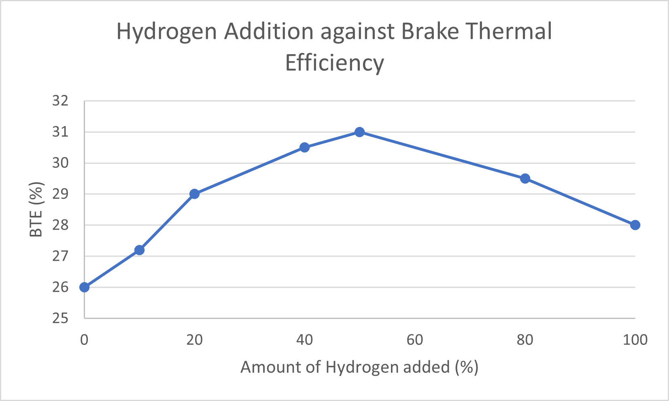
Figure 2: Variation of brake thermal efficiency with hydrogen concentration under stoichiometric operating conditions at 2500 rpm.
4.3 Effect of Hydrogen Concentration on Brake-Specific Energy Consumption (BSEC)
The BSEC decreased progressively with increasing hydrogen concentration, indicating improved fuel energy utilization. The minimum BSEC value of approximately 11.0 MJ/kWh was observed at 50% hydrogen addition, corresponding to the condition of maximum BTE. Figure 3 illustrates the effect of hydrogen enrichment on brake-specific energy consumption.
The reduction in BSEC is primarily attributed to improved combustion efficiency resulting from hydrogen’s superior combustion properties, including high flame velocity, low quenching distance, and enhanced diffusivity. These characteristics promote rapid flame development and reduce combustion duration, thereby increasing the fraction of released energy converted into useful work.
Compared with neat gasoline operation, the introduction of 50% hydrogen resulted in an approximate 19.7% reduction in BSEC, demonstrating substantial improvement in fuel energy utilization.
At higher hydrogen concentrations, the reduction in BSEC became less significant due to increased thermal losses associated with elevated in-cylinder temperatures.
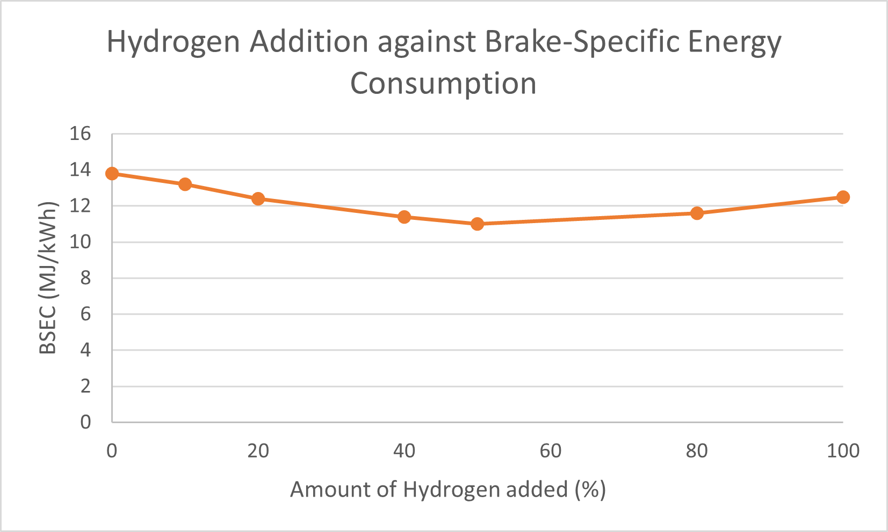
Figure 3: Variation of brake-specific energy consumption with hydrogen concentration under stoichiometric operating conditions at 2500 rpm.
4.4 Effect of Hydrogen Concentration on CO Emissions
A substantial reduction in CO emissions was observed with increasing hydrogen enrichment. Since hydrogen contains no carbon atoms, its addition reduces the carbon content of the fuel mixture and promotes more complete combustion. At moderate hydrogen enrichment levels, CO emissions decreased significantly, reaching approximately 0.9% at 50% hydrogen concentration. This represents approximately a 82.7% reduction compared with neat gasoline operation. The improved oxidation process can be attributed to enhanced combustion efficiency, reduced quenching effects, and increased flame propagation speed. The variation of CO emissions with hydrogen concentration is shown in Figure 4. Under pure hydrogen operation, CO emissions approached nearly zero levels, with only trace emissions potentially originating from lubricant oil combustion or residual hydrocarbon deposits within the combustion chamber.
These findings confirm the strong potential of hydrogen enrichment for reducing carbonaceous emissions in spark-ignition engines.
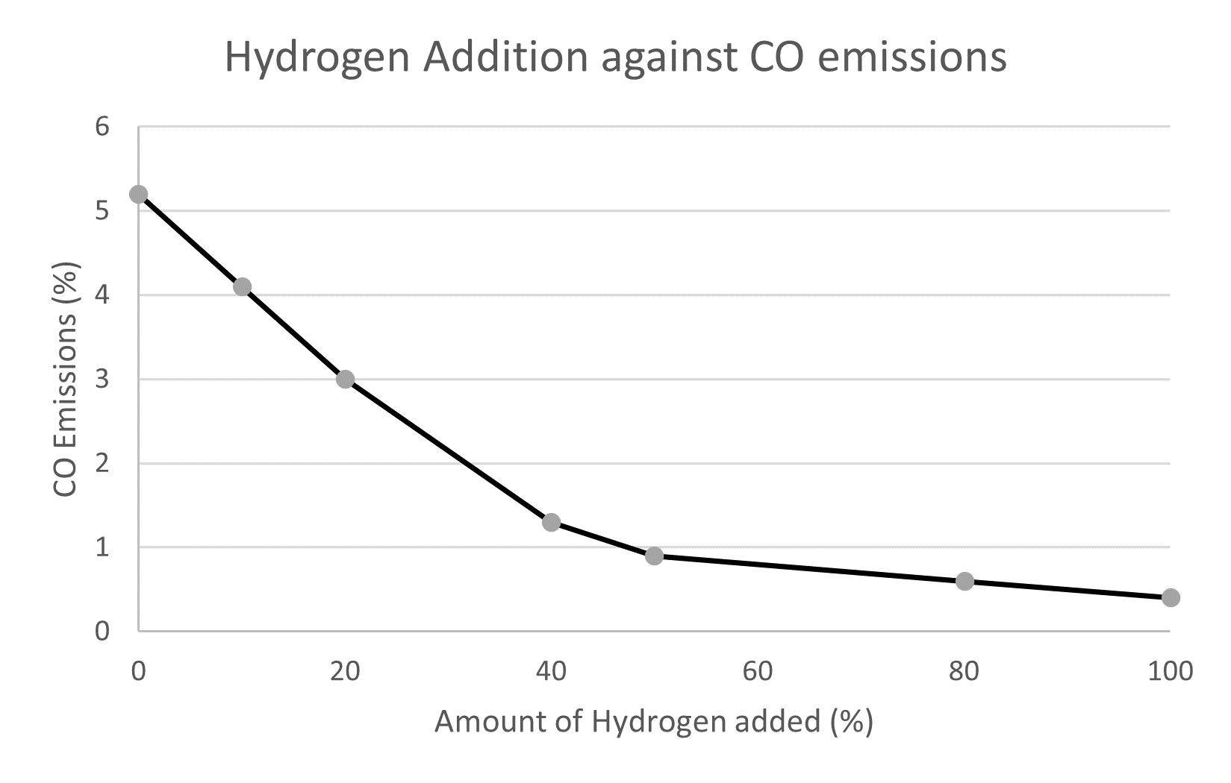
Figure 4: Variation of CO emissions with hydrogen concentration under stoichiometric operating conditions at 2500 rpm.
  - Effect of Hydrogen Concentration on NOx Emissions
The NOx emissions increased with increasing hydrogen fraction due to elevated combustion temperatures and accelerated heat release rates associated with hydrogen combustion. At moderate hydrogen enrichment, NOx formation increased substantially, reaching approximately 1025 ppm at 50% hydrogen concentration. This corresponds to approximately a 21.5% increase relative to neat gasoline operation. Ji and Wang (2010) reported that hydrogen enrichment improves combustion efficiency while simultaneously increasing NOx emissions due to elevated flame temperatures. Similar trends were observed in the present study. The increase in NOx emissions is mainly attributed to thermal NOx formation via the extended Zeldovich mechanism, which becomes dominant at high in-cylinder temperatures.
Hydrogen’s high flame speed and rapid combustion characteristics promote higher peak temperatures and enhanced local thermal gradients within the combustion chamber. Consequently, the rate of thermal NOx formation increases significantly under stoichiometric conditions. At 100% hydrogen operation, NOx emissions remained considerably high because hydrogen combustion produces very high adiabatic flame temperatures under stoichiometric conditions. Figure 5 presents the variation of NOx emissions with hydrogen concentration.
Although hydrogen enrichment improves efficiency and reduces carbon emissions, the associated increase in NOx emissions remains a major challenge for practical implementation. Consequently, NOx mitigation strategies such as exhaust gas recirculation (EGR), lean-burn operation, water injection, or advanced after-treatment systems may be necessary.

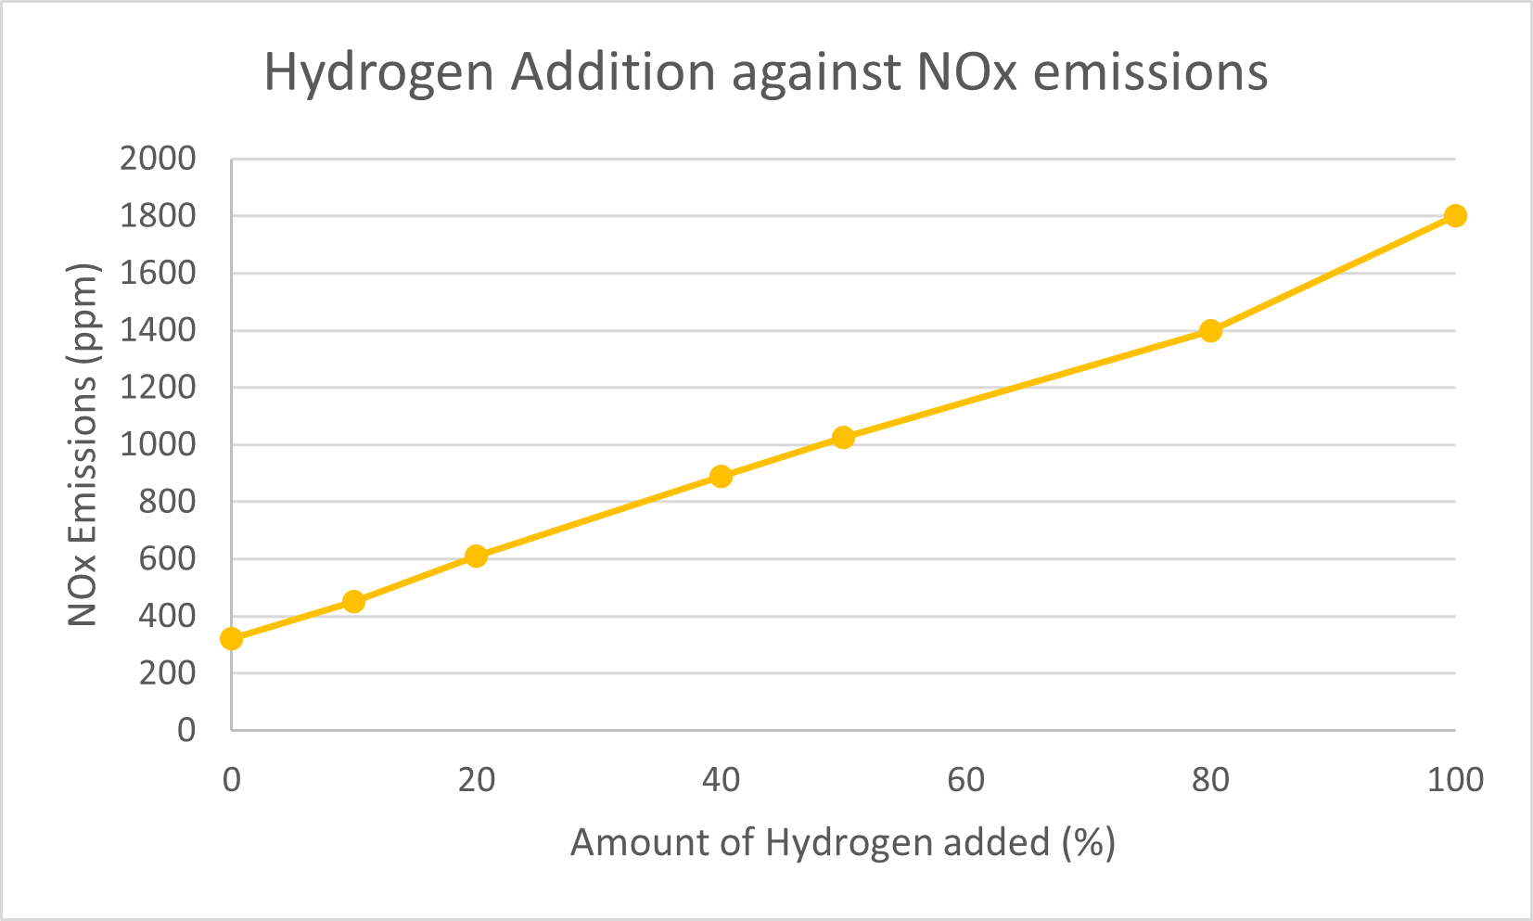
Figure 5: Variation of NOx emissions with hydrogen concentration under stoichiometric operating conditions at 2500 rpm.
  - Model Validation and Limitations
To ensure the reliability of the simulation results, the AVL model was developed using established combustion and emission sub-models for spark-ignition engines. The simulation framework incorporated detailed combustion kinetics and thermodynamic modelling to predict engine performance and emission characteristics under hydrogen-enriched operating conditions.
The trends obtained from the simulation were found to be consistent with previously published experimental and numerical studies on hydrogen–gasoline dual-fuel combustion. In particular, the observed increase in brake thermal efficiency and reduction in CO emissions with hydrogen enrichment agree well with findings reported in the literature. Pourkhesalian et al. (2010) observed that hydrogen’s high laminar flame speed and low quenching distance improve combustion efficiency and reduce incomplete combustion products. Their findings regarding increased NOx formation with hydrogen enrichment are also consistent with the current study. A notable distinction between the present work and previous investigations lies in the optimum hydrogen concentration. While Purayil et al. (2023) suggested that higher hydrogen fractions may further enhance engine performance, the present study identified 50% hydrogen enrichment as the most favourable operating condition considering both efficiency improvement and emission behaviour.
The differences observed among studies may result from variations in engine geometry, operating conditions, equivalence ratio, ignition timing, and simulation methodology. Consequently, future studies should investigate advanced NOx reduction strategies such as EGR, water injection, and lean-burn combustion to maximize the benefits of hydrogen enrichment while minimizing emission penalties. Nevertheless, the present study is limited to stoichiometric operation at a fixed engine speed, compression ratio, and ignition timing. Variations in operating parameters such as lean-burn conditions, exhaust gas recirculation rates, spark timing optimisation, and transient engine operation were not considered.
Future studies should incorporate experimental validation, detailed in-cylinder pressure analysis, heat release analysis, and advanced NOx mitigation strategies to further improve the predictive capability and practical relevance of the model.

5.0 Conclusion
This study investigated the performance and emission characteristics of a spark ignition (SI) engine operating with a hydrogen–gasoline dual-fuel system, with the aim of identifying suitable operating conditions for improved engine performance and reduced exhaust emissions, particularly nitrogen oxides (NOx). The results demonstrate that hydrogen enrichment can significantly improve spark-ignition engine efficiency while simultaneously reducing carbon-based emissions thus supporting the development of cleaner engine technologies.
The following conclusions can be drawn from the study:
- Hydrogen enrichment improved brake thermal efficiency due to enhanced combustion characteristics, with the optimum performance observed at approximately 50% hydrogen concentration.
- Brake-specific energy consumption decreased with increasing hydrogen fraction, indicating improved fuel energy utilization.
- The introduction of hydrogen also resulted in substantial reductions in carbon monoxide (CO) and hydrocarbon (HC) emissions, indicating improved combustion quality and reduced carbon-based pollutants.
- NOx emissions increased with hydrogen enrichment due to elevated combustion temperatures associated with hydrogen combustion.
- The results suggest that moderate hydrogen enrichment provides an effective compromise between engine efficiency and emission performance.
The implications of this study extends to environmental sustainability, engine development, and the global transition toward alternative energy sources. Hydrogen–gasoline dual-fuel systems offer the potential to reduce greenhouse gas emissions and improve air quality by lowering carbon-based pollutants. The findings also provide valuable insight for the design and optimisation of future SI engines capable of operating efficiently with hydrogen-based fuel mixtures, thereby contributing to cleaner and more sustainable transportation technologies.
Although challenges such as NOx formation, hydrogen storage, system cost, and long-term engine durability remain, this study demonstrates that moderate hydrogen enrichment appears more practical for real-world applications than complete hydrogen substitution because it provides substantial efficiency benefits while maintaining manageable combustion behaviour.
Further research should focus on experimental validation of the simulation results, the application of advanced combustion control strategies for NOx reduction, and the evaluation of the long-term reliability and economic feasibility of hydrogen–gasoline dual-fuel systems. Continued innovation in this field will be essential in supporting the transition toward low-carbon energy solutions and more sustainable mobility.

REFERENCES
Akif Ceviz, M., Sen, A. K., Küleri, A. K., & Volkan Öner, İ. (2012). Engine performance, exhaust emissions, and cyclic variations in a lean-burn SI engine fueled by gasoline–hydrogen blends. Applied Thermal Engineering, 36, 314-324. https://doi.org/10.1016/j.applthermaleng.2011.10.039.
Altair (n.d.) AVL CRUISE M. Available at: https://altair.com/avl-cruise-m.
Bae, C., & Kim, J. (2016). Alternative fuels for internal combustion engines. Proceedings of the Combustion Institute, 36(3), 3389-3413. Available at: https://doi.org/10.1016/j.proci.2016.09.009.
Ciniviz, M. and Kose, H. (2012) ‘Hydrogen use in internal combustion engines: A review’, International Journal of Automotive Engineering and Technologies, 1, pp. 1–15. Available at: https://www.scirp.org/reference/referencespapers?referenceid=1546586.
Coronado, C. J., Carvalho, J. A., Andrade, J. C., Cortez, E. V., Carvalho, F. S., Santos, J. C., & Mendiburu, A. Z. (2012). Flammability limits: A review with emphasis on ethanol for aeronautical applications and description of the experimental procedure. Journal of Hazardous Materials, 241-242, 32-54. Available at: https://doi.org/10.1016/j.jhazmat.2012.09.035.
Das, L.M. (2002) ‘Hydrogen engines: A view of the past and a look into the future’, International Journal of Hydrogen Energy, 27(5), pp. 479–487.
Dunn, S. (2002) ‘Hydrogen futures: Toward a sustainable energy system’, International Journal of Hydrogen Energy, 27(3), pp. 235–264. Available at: https://doi.org/10.1016/s0360-3199(01)00131-8.
Hamada, K.I., Rahman, M.M., Ramasamy, D., Noor, M.M. and Kadirgama, K. (2016) ‘Numerical investigation of in-cylinder flow characteristics of hydrogen-fuelled internal combustion engine’, Journal of Mechanical Engineering and Sciences, 10(1), pp. 1782–1802. Available at: https://doi.org/10.15282/jmes.10.1.2016.4.0172.
Ji, C. and Wang, S. (2010) ‘Effect of hydrogen addition on combustion and emissions performance of a spark ignition gasoline engine at lean conditions’, International Journal of Hydrogen Energy, 35(13), pp. 6583–6591. Available at: https://doi.org/10.1016/j.ijhydene.2009.06.082.
Kahraman, E., Cihangir Ozcanlı, S., & Ozerdem, B. (2007). An experimental study on performance and emission characteristics of a hydrogen fuelled spark ignition engine. International Journal of Hydrogen Energy, 32(12), 2066-2072. https://doi.org/10.1016/j.ijhydene.2006.08.023.
Karim, G. (2003) ‘Hydrogen as a spark ignition engine fuel’, International Journal of Hydrogen Energy, 28(5), pp. 569–577. Available at: https://doi.org/10.1016/s0360-3199(02)00150-7.
Lapuerta, M., Hernández, J. P., & Agudelo, J. R. (2014). An equation for the estimation of alcohol-air diffusion coefficients for modelling evaporation losses in fuel systems. Applied Thermal Engineering, 73(1), 539-548. Available at: https://doi.org/10.1016/j.applthermaleng.2014.08.009.
Log, T., & Moi, A. L. (2018). Ethanol and Methanol Burn Risks in the Home Environment. International Journal of Environmental Research and Public Health, 15(11), 2379. Available at: https://doi.org/10.3390/ijerph15112379.
Nayak V., Shankar K. S., Dinesha P. and Mohanan P. (2017) An experimental investigation on performance and emission parameters of a multi-cylinder SI engine with gasoline-LPG dual fuel mode of operation. Biofuels, 8 (1), pp. 113-123
Niculae, N., Pana, C. and Cernat, A. (2012) ‘Aspects of using hydrogen in SI engine’, UPB Scientific Bulletin, Series D: Mechanical Engineering, 74.
Nguyen, D., Kar, T. and James (2023) ‘Performance, emissions, and combustion characteristics of a hydrogen-fuelled spark-ignited engine at different compression ratios: Experimental and numerical investigation’, Energies, 16(15), p. 5730. Available at: https://doi.org/10.3390/en16155730.
Ogden, J.M. (2018) Prospects for hydrogen in the future energy system. Available at: https://escholarship.org/uc/item/52s28641.
Pourkhesalian, A. M., Shamekhi, A. H., & Salimi, F. (2010). Alternative fuel and gasoline in an SI engine: A comparative study of performance and emissions characteristics. Fuel, 89(5), 1056-1063. https://doi.org/10.1016/j.fuel.2009.11.025.
Purayil, S.T.P., Al-Omari, S.A.B. and Elnajjar, E. (2023) ‘Effect of hydrogen blending on the combustion performance, emission, and cycle-to-cycle variation characteristics of a single-cylinder GDI spark ignition dual-fuel engine’, International Journal of Thermofluids, 20, p. 100403. Available at: https://doi.org/10.1016/j.ijft.2023.100403.
Purayil, S.T.P., Hamdan, M.O., Al-Omari, S.A.B. and Selim, M.Y.E. (2023) ‘Review of hydrogen–gasoline SI dual fuel engines: Engine performance and emission’, Energy Reports, 9, pp. 4547–4573. Available at: https://doi.org/10.1016/j.egyr.2023.03.054.
Stępień, Z. (2021) ‘A comprehensive overview of hydrogen-fuelled internal combustion engines: Achievements and future challenges’, Energies, 14(20), p. 6504. Available at: https://doi.org/10.3390/en14206504.
Verhelst, S. and Wallner, T. (2009) ‘Hydrogen-fuelled internal combustion engines’, Progress in Energy and Combustion Science, 35(6), pp. 490–527.
Wikipedia Contributors (2019) Ansys. Available at: https://en.wikipedia.org/wiki/ANSYS.
Wróbel, K., Wróbel, J., Tokarz, W., Lach, J., Podsadni, K. and Czerwiński, A. (2022) ‘Hydrogen internal combustion engine vehicles: A review’, Energies, 15(23), p. 8937. Available at: https://doi.org/10.3390/en15238937.
Xu, L. and Bai, X. (2023) ‘Numerical investigation of engine performance and emission characteristics of an ammonia/hydrogen/n-heptane engine under RCCI operating conditions’, Flow, Turbulence and Combustion. Available at: https://doi.org/10.1007/s10494-023-00453-y.
Yan, F., Xu, L. and Wang, Y., 2018. Application of hydrogen enriched natural gas in spark ignition IC engines: From fundamental fuel properties to engine performances and emissions. Renewable and Sustainable Energy Reviews, 82, pp.1457-1488. Available at: https://doi.org/10.1016/j.rser.2017.05.227.
Zaharin, M., Abdullah, N., Masjuki, H., Ali, O. M., Najafi, G., & Yusaf, T. (2018). Evaluation on physicochemical properties of iso-butanol additives in ethanol-gasoline blend on performance and emission characteristics of a spark-ignition engine. Applied Thermal Engineering, 144, 960-971. Available at: https://doi.org/10.1016/j.applthermaleng.2018.08.057.
Zhao, A. (n.d.) GT-SUITE. Available at: https://www.gtisoft.com/gt-suite/.

