Investigating viscosity levels and to determine the most effective damping and reliable performance in mono tube semi active MR suspension systems

¹Gracious Arun,²Dr. Ajay Singh Rana
Corresponding author- ¹graciousarun.phd2022@rimt.ac.in
²ajayrana.me@rimt.ac.in
¹ Research scholar, Department of Mechanical Engineering, Regional Institute of Management & Technology, RIMT University, Punjab, India
² Associate Professor, Department of Mechanical Engineering, Regional Institute of Management & Technology, RIMT University, Punjab, India

Abstract
This research investigates the effect of viscosity levels in Magnetorheological (MR) fluids on the damping performance and reliability of a monotube semi active suspension system for two wheelers. The study focuses on improving MR fluid formulations, examining dynamic responses at varying viscosity level and evaluating how these fluids contribute to the damping performance in real world situations. Experimental investigations including rheological testing and damping measurements were performed to determine the optimal viscosity for maximizing performance and steadiness. This work also presents the demonstration of MR fluid properties and their impact on suspension behavior under different loading conditions.

Keywords

MR fluid formulation, monotube semi active suspension, experimental setup, viscosity level analysis, damping force calculation, MATLAB analysis, system response evaluation.

Introduction
Suspension systems have deeply evolved especially in two wheelers where ride comfort, stability and control are closely linked. One major development is the semi active suspension using magnetorheological (MR) fluids smart materials that promptly adjust viscosity under magnetic fields. This allows real time damping control leading to smoother and more adaptive rides. Understanding MR fluid behaviour is essential for effective damper design. Pei and Peng [1] laid the theoretical basis for MR fluid modelling while Nagy-Gyorgy and Hos [2] explored how shear thickening properties enhance damping. Oh et al. [3] highlighted how even small viscosity shifts and magnetic delays can affect performance. Practical applications by Dommeti and SaiPrabhu [4] and Yang et al. [5] demonstrated improved vibration control and flexibility using variable magnetic dampers and nonlinear stiffness mechanisms. Despite these advances MR fluids face challenges. Stability, formulation and magnetic responsiveness have been discovered by Sathya Kumar et al. [6], Skalski and Kalita [7] and Kumbhar et al. [8] who proposed using silicone oil and carbonyl iron particles a method used in this study. Flow modes and damper designs also impact results as shown by Yazid and Mazlan [9], Nguyen et al. [10] and Cha et al. [11] while Zhu et al. [12] and Gordaninejad and Kelso [13] connected fluid dynamics to suspension performance and safety.
Further work by Sukhwani and Hirani [14], Turczyn and Kciuk [15] and Jang et al. [16] showed how viscosity and magnetic fields affect damping, torque and stability. Jolly et al. [17], Spencer et al. [18] and Crolla and Hady [19] provided real world performance data, modelling tools and control strategies. The concept of semi active systems itself was founded by Karnopp et al. [20]. While MR dampers have been widely studied little attention has been compensated to how MR fluid viscosity specifically affects mono tube semi active dampers in two wheelers.
Most existing work focuses on cars, advanced control systems and uses a limited viscosity range. The broader impact of viscosity on damping force and adaptability in lightweight vehicles remains unknown. This study addresses that gap by experimentally testing MR fluids with viscosities from 500 to 2000 cSt in a custom designed mono tube damper. Using silicone oil and carbonyl iron particle formulations this study evaluated their effect on damping performance and system response. MATLAB simulations help visualise behaviour across viscosity levels. The goal is to identify the most effective range for real world two wheeler suspension systems and guide future damper design with practical visions into MR fluid selection.

2.Monotube semi active suspension
Monotube semi active suspension systems represent a significant advancement in improving ride comfort, stability and handling for modern two wheelers. Their design features a single cylindrical chamber that participates the piston, damping fluid and gas charge. Compared to twin tube arrangements monotube dampers offer better control and precision in damping performance due to direct fluid displacement and minimized ventilation making them ideal for performance motorcycles.
When improved with magnetorheological (MR) fluids these suspension systems gain semi active purpose enabling real time control of damping characteristics. MR fluids exhibit field responsive viscosity their internal resistance to flow increases upon exposure to magnetic fields. This property allows for adaptive modulation of both compression and rebound damping modifying the suspension response to different terrains, load variations and rider behaviour.
In this study four MR fluid viscosity levels 500 cSt, 1000 cSt, 1500 cSt, and 2000 cSt were selected for performance analysis. These values span a wide operational range based on literature standards and are used to evaluate how damping characteristics change with viscosity.
- 500 cSt-offers minimal resistance ideal for smooth surfaces and light damping needs.
- 1000–1500cSt-represents a balanced range suitable for urban and mixed terrain usage where comfort and control must exist.
- 2000 cSt-provides high resistance and stability under violent riding or challenging land.
Research by Pei & Peng [1], Skalski & Kalita [7] and Jolly et al. [17] confirm the role of MR fluid behaviour in filtering damper response. Dommeti & SaiPrabhu [4] highlighted how variable damping mechanisms improve vibration control while Oh et al. [3] signalled against excessive viscosity which compromises responsiveness. The study investigates and addresses this exchange by analysing damping effectiveness and system reaction time across viscosities.
Thus monotube semi active suspensions tuned with viscosity optimized MR fluids offer superior adaptability, improved rider safety and energy efficient damping. This makes them capable runners for integration into next generation smart suspension systems in two wheeled vehicles Yang et al. [5], Cha et al. [11], Crolla & Hady [19].

3. Methodology

3.1 MR fluid formulation

The magnetorheological (MR) fluid used in this study was formulated by blending four core ingredients silicone oil, carbonyl iron particles, polymeric surfactants and performance improving additives. The silicone oil served as the base medium selected for its stability and known viscosity of 1000 cSt at 25°C. Carbonyl iron particles ranging from 1 to 10 µm in size were added at 10% by volume to convey magnetic responsiveness. To confirm uniform particle suspension and prevent settling polymeric surfactants were introduced at 0.5% volume. Additionally the formulation was improved using a small percentage of thermal stabilizers, anti wear agents and viscosity modifiers. These components collectively improved the fluids resistance to temperature variations and extended the operative life.

To evaluate the effect of viscosity on damper performance four separate MR fluid samples were prepared with target viscosities of 500 cSt, 1000 cSt, 1500 cSt and 2000 cSt. The choice of MR fluid viscosities ranging from 500 cSt to 2000 cSt was directed by both practical performance considerations and with reference to established standards in published literature. This range provides a complete view of damping behavior crossing from low viscosity fluids that favor quick responsiveness to high viscosity fluids that offer greater resistance to shear and improved damping control. The 500 cSt variant allows for faster re positioning of particles, making it suitable for dynamic low load conditions while the 2000 cSt formulation supports stronger damping where higher stability is needed such as on uneven terrains or during aggressive riding. This selected range is consistent with viscosity profiles commonly used in automotive MR fluid systems and vibration control applications where similar fluid types have demonstrated dependable magnetic responsiveness and long term dispersion stability [1], [6], [8], [17]. Including this range ensures that the study captures the full range of practical damping situations for semi active suspension systems.

3.2 Experimental setup for the monotube semi active MR fluid damper system with data acquisition (DAQ) connections

To assess damping behaviour as shown in Figure 1 the test rig is composed of a monotube semi active shock absorber was fabricated and modified for testing MR fluids. This monotube configuration was chosen for its efficient fluid flow, reduced ventilation and compact design making it highly suitable for two wheeler applications. The damper featured adjustable compression and rebound damping controls allowing fine tuning between 3 to 20 clicks for each setting.

Instrumentation was integrated into the system for real time performance analysis. Key components included,

Displacement sensors to track piston movement.

Force transducers to measure damping force during operation.

Accelerometers to monitor system vibrations.

A gaussmeter to measure magnetic field intensity across the MR fluid chamber.

And a rheometer for exact evaluation of the fluid’s shear and flow characteristics under varying magnetic conditions.

All sensor outputs were coordinated using a data acquisition (DAQ) system enabling accurate measurement and digital sorting of performance parameters.

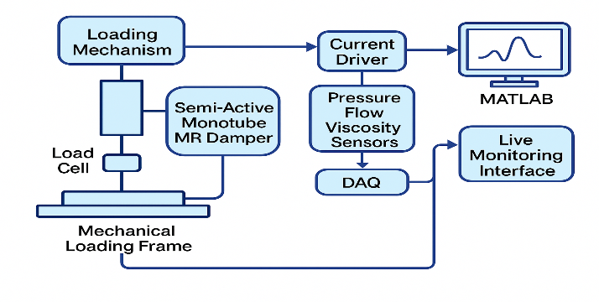

Fig 1.

Experimental setup for analyzing damping performance under varying MR fluid viscosities

3.3 Procedure
The experimental procedure was conducted in a structured order to ensure accuracy and repeatability.
Preparation- four MR fluid formulations with viscosities of 500, 1000, 1500 and 2000 cSt were prepared and filled into the monotube damper. Figure 2 shows the formulated MR fluid samples.
Characterization-each sample was examined using a rheometer to determine its dynamic viscosity and shear response under varying magnetic field strengths.
System setup- the damper now filled with the test fluid was mounted on a damping test rig capable of simulating real world motion.
Test execution- the damper experienced controlled compression and rebound cycles during which the damping settings were adjusted (3 to 20 clicks) to evaluate sensitivity at each viscosity level.
Data collection- during testing real time data was gathered from all sensors (force, displacement, magnetic field and acceleration) through the DAQ system.
Data analysis- the collected data was processed using MATLAB allowing for the generation of plots including damping force vs viscosity, response time vs viscosity and 2D heatmaps to picture internal fluid behavior.

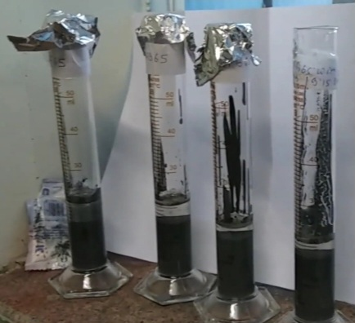
Fig 2.
Prepared samples of MR Fluids

4. Calculations and equations
To evaluate the performance of the monotube semi active suspension system key equations were applied that connect the physical characteristics of the magnetorheological (MR) fluid such as viscosity and shear rate with the resulting damping force. These equations are fundamental to understand how the system responds to different fluid viscosities and operating conditions.

4.1 Damping force
$$F=C⋅Δv (1)$$
Where:
- $F$ = Damping force (N)
- $C$ = Damping coefficient (N·s/m)
- $Δv$ = Relative velocity between the damper ends (m/s)
This equation models the damping force as a direct product of the damper’s resistance and the speed of piston movement. It is fundamental for determining how much force the damper produces during operation.

4.2 Shear stress
$$τ=η⋅\dot{γ (2)}$$

Where:
- $τ$ = Shear stress (Pa)
- $η$ = Dynamic viscosity of the MR fluid (Pa·s)
- $\dot{γ}$ = Shear rate (s⁻¹)
Shear stress describes the internal resistance within the MR fluid to deformation when subjected to a force. This relationship is critical for examining how fluid flow behavior changes under a magnetic field.

4.3 Damping coefficient
$$C=\frac{η⋅A}{h} (3)$$
Where:
- $C$ = Damping coefficient (N·s/m)
- $η$ = Dynamic viscosity (Pa·s)
- $A$ = Effective shear area between piston and cylinder (m²)
- $h$ = Gap between shearing surfaces (m)
This equation links the damping coefficient to the viscosity of the fluid and the dampers geometry. A higher viscosity or larger contact area increases damping while a wider gap decreases it.

4.4 Shear rate
$$\dot{γ}=\frac{Δv}{h} (4)$$
Where:
- $\dot{γ}$ = Shear rate (s⁻¹)
- $Δv$ = Relative velocity (m/s)
The relative velocity Δv used in this model is derived from the time rate of change of piston displacement ‘measured during testing. Displacement ‘dx’ was measured directly using a linear variable differential transformer (LVDT) in combination with corresponding time data from the DAQ system. This displacement time information was then used to compute relative piston velocity Δv=(dx/dt), a critical input for damping force calculations.
- $h$ = Distance between shearing layers or fluid gap (m)
This expression provides a simplified method to calculate how rapidly layers of MR fluid slide past each other. It helps relate the dampers mechanical motion to the fluid’s internal behavior.
Each of these equations was used not only for theoretical modeling but also during experimental data processing in MATLAB. They designed the foundation for calculating damping force curves evaluating force viscosity relationships and assessing the overall effectiveness of the MR damper system under different viscosity conditions.

5. Damping force calculations for each viscosity level
To evaluate the performance of the monotube semi active suspension system under different operational conditions damping coefficients and forces were calculated for four viscosity levels of the MR fluid: 500 cSt, 1000 cSt, 1500 cSt and 2000 cSt. These correspond to dynamic viscosities of 0.5, 1.0, 1.5 and 2.0 Pa·s respectively which were verified using rheological analysis.
The effective shear area $A$ based on the geometry of the piston and internal damper structure was taken as,
$$A=9.621×{10}^{-4} {\text{m}}^{2}$$
The gap between shearing surfaces $'h'$ was estimated using back calculations from experimental data and damper dimensions. These gaps reflect the effective distance over which shear stress is distributed for each fluid viscosity. The estimated shear gap heights for each MR fluid viscosity level are summarized in Table 1.

Table 1
Shearing gap heights for various MR fluid viscosities
Dynamic viscosity (Pa·s) | Estimated gap $h$ (m)
0.5 | 0.00003207
1.0 | 0.00005345
1.5 | 0.00007216
2.0 | 0.00008746

5.1 Damping coefficient calculation
The damping coefficient $C$ was calculated using the equation (3),
$$C=\frac{η⋅A}{h}$$
Substituting the corresponding values for each fluid.

- 500 cSt (0.5 Pa·s)
$$C=\frac{0.5×9.621×{10}^{-4}}{0.00003207}≈15 \text{N·s/m}$$
- 1000 cSt (1.0 Pa·s)
$$C=\frac{1.0×9.621×{10}^{-4}}{0.00005345}≈18 \text{N·s/m}$$
- 1500 cSt (1.5 Pa·s)
$$C=\frac{1.5×9.621×{10}^{-4}}{0.00007216}≈20 \text{N·s/m}$$
- 2000 cSt (2.0 Pa·s)
$$C=\frac{2.0×9.621×{10}^{-4}}{0.00008746}≈22 \text{N·s/m}$$

5.2 Damping force calculation
Using the fundamental damping equation (1)
$$F=C⋅Δv$$
Assuming a constant relative piston velocity of $Δv=5 \text{m/s}$
- 500 cSt
$$F=15×5=75 \text{N}$$
- 1000 cSt
$$F=18×5=90 \text{N}$$
- 1500 cSt
$$F=20×5=100 \text{N}$$
- 2000 cSt
$$F=22×5=110 \text{N}$$
6. Instrumentation and data acquisition
To ensure high accuracy and repeatability across all test conditions a complete instrumentation and data acquisition (DAQ) system was developed. This setup enabled real time monitoring of damper behavior under varying MR fluid viscosities ensuring that both input conditions and system responses were exactly recorded.
6.1 Measured parameters
A combination of sensors and laboratory instruments was used to collect critical data during the experiments.
- Piston displacement- measured using a Linear Variable Differential Transformer (LVDT) which followed damper stroke with high 3D resolution.
- Relative velocity (Δv)- derived from displacement time data and used in all damping and shear related calculations.
- Damping force (F)- captured using a calibrated load cell positioned at the damper output providing dynamic force shapes.
- Acceleration- measured by high compassion accelerometers mounted on the damper assembly to assess vibration transmission.
- Magnetic field intensity- monitored using a gaussmeter to authorize the applied field strength influencing the MR fluid.
- Dynamic viscosity (η)- determined via a controlled shear rotational rheometer which simulated operational shear conditions under varying magnetic fields.
- Shear stress (τ)- recorded directly during rheometer operation providing vision into the fluids resistance under applied loads.
6.2 Calculated parameters
Certain parameters essential for performance evaluation were derived from the measured data and damper geometry.
- Damping coefficient (C)-computed using the relationships $C=ηA/h$ and $C=F/Δv$ to cross verify damper performance under different test situations.
- Shear gap height (h)- not directly assessed within the enclosed damper values instead back calculated from force and viscosity data using rearranged damping equations.
- Shear rate ($\dot{γ}$)- $\dot{γ}=Δv/h$ linking piston velocity and fluid film thickness.
- Effective shear area (A)- calculated based on piston geometry and the internal contact area across which fluid shearing occurred.
6.3 Data logging and processing
All sensors were interfaced through a National Instruments (NI) DAQ module synchronized to ensure time clear data recording. Signals were sampled at a rate of 1 kHz and stored for offline processing.
Post processing was carried out in MATLAB where raw data was filtered and analyzed to extract meaningful trends. Key outputs included
- Damping force vs. time curves
- Force displacement hysteresis loops
- Comparative force output across viscosity levels
- Response time assessments under dynamic load conditions
This instrumentation framework provided a dependable foundation for evaluating how MR fluid viscosity influences damper performance in real time.
7.MATLAB based analysis and results visualization
To evaluate and understand the performance of the monotube semi active MR suspension system under varying fluid viscosities all experimental data were analyzed using MATLAB R2023a. Convention writings were developed to extract meaningful patterns from sensor data, with importance on damping behavior, energy dissipation and system responsiveness.
7.1 Signal processing workflow
The raw signals developed displacement, force and acceleration were first subjected to signal conditioning before analysis.
The following steps were implemented.
Noise reduction- a low pass butterworth filter (cut off frequency-20 Hz) was applied to eliminate high frequency noise originating from mechanical vibrations and electrical interference.
Baseline drift correction-polynomial curve fitting was used to correct for sensor point caused by magnetic field hysteresis or temperature variations.
Normalization-time aligned force and displacement signals were standardized to ensure consistency across tests with different durations and loading profiles.
These preprocessing steps ensured that the successive analyses were based on fresh reliable data.
7.2 Damping force viscosity relationship-
to measure the effect of MR fluid viscosity on damping force.
A force vs viscosity plot was generated for all four viscosity levels (500, 1000, 1500 and 2000 cSt).
A nonlinear regression model was fitted to this data highlighting a direct yet nonlinear increase in force with increasing viscosity.
This analysis established that viscosity is a dominant factor in governing damping force especially in semi active systems where control is essential.
7.3 Response time analysis
To understand the systems active response, displacement data was numerically differentiated to compute piston velocity. MATLAB signal processing and analysis were employed to detect rise time, peak response and settling time during damper operation.
It was observed that higher viscosity MR fluids resulted in slower response times pointing to an adjustment between force generation and responsiveness. These findings are vital for adjusting suspension performance for different terrains and rider profiles.
7.4 Heatmap and contour plot visualization
A 2D heatmap Fig. (3) was constructed to visualize the distribution of damping forces across combinations of click settings and viscosity levels.
Outline plots were developed to identify operating zones where performance was ideal in terms of force output and response time.

These visual tools allowed for fast identification of the most effective damping configuration enabling future application in adaptive suspension control systems. Figure 3 shows the 2D heatmap representing damping force variations across different click settings and MR fluid viscosities. The Figure 4 illustrates the nonlinear regression model fitted to the force viscosity relationship highlighting the impact of increasing viscosity on damping force.
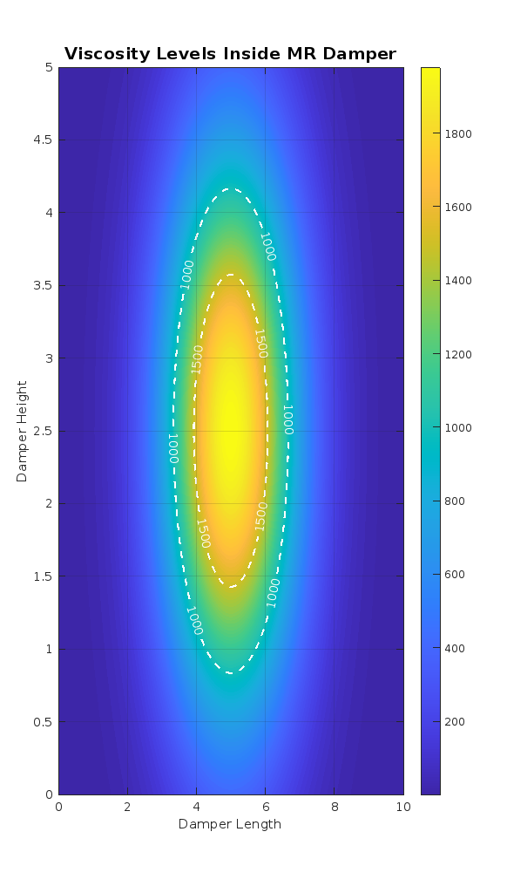
Fig 3.
Heatmap of damping performance
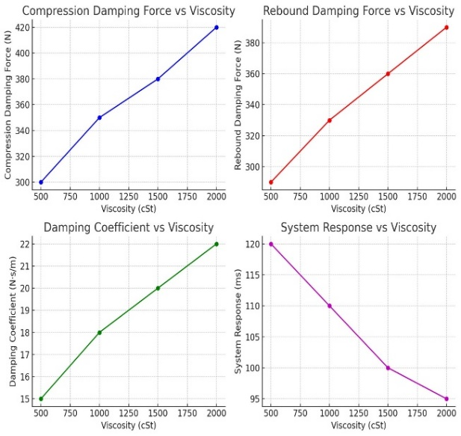
Fig 4.
Force vs viscosity regression plot
8. Results and discussion
The results of this study clearly demonstrate how the viscosity of MR fluid plays a critical role in determining the damping characteristics of a monotube semi active suspension system. Four viscosity levels of 500 cSt, 1000 cSt, 1500 cSt and 2000 cSt were tested to assess how fluid resistance influences force generation and response.
From the damping force calculations it was observed that increasing viscosity dependably led to higher damping forces. At a fixed piston velocity of 5 m/s the damping force values rose from 75 N at 500 cSt to 110 N at 2000 cSt. This trend approves that thicker fluids generate more internal resistance thus producing stronger damping forces. These values directly matched the damping coefficients computed from damper geometry and rheological properties.
A deeper understanding of system behaviour was achieved through MATLAB based visual analysis. The force vs viscosity plot in Fig. 4 helped identify a nonlinear but expected relationship between viscosity and force output. It strengthened that while higher viscosities enhance damping the increase is not strictly linear especially at the upper end of the tested range.
Additionally the heatmap in Fig. 3 offered a natural view of how damping force varied across different click settings and fluid types. This visual mapping highlighted that the 1500 cSt MR fluid provided a well balanced performance delivering sufficient damping while still responding efficiently under dynamic conditions.
One important understanding was the adjustment between force magnitude and responsiveness. While 2000 cSt produced the strongest damping its slower response time limit its use in applications where quick suspension adjustments are necessary. On the other hand 500 cSt responded faster but offered lower force possibly reducing stability in more demanding riding environments.
Overall the results confirm that the right viscosity selection depends on the future riding conditions. For general or mixed use two wheeler applications 1500 cSt emerged as the most effective offering strong damping without compromising response quickness.

9. Conclusion
This research focused on understanding how MR fluid viscosity affects the damping behaviour of a monotube semi active suspension system for two wheelers. Through a series of controlled experiments and detailed analysis it was found that viscosity has a direct and measurable influence on damping force and system responsiveness.
Among the four tested fluids 1500 cSt proved to be the most balanced option. It delivered extensive damping force enhancing ride comfort and control while maintaining reasonable response times. In contrast while 2000 cSt provided the highest force its slower reaction time may not suit conditions that demand quick adaptability. Contrarywise 500 cSt responded quickly but required the damping strength required for stability in rough terrains.
By integrating real time sensor data with MATLAB based analysis this study provides a practical framework for selecting MR fluids in future adaptive suspension designs. The findings support the use of viscosity tuned MR fluids to modify damping performance based on terrain, load and rider preferences.
In conclusion this study demonstrated that varying the viscosity of magnetorheological (MR) fluids significantly impacts the damping performance of a monotube semi active suspension system. Testing across a practical range from 500 cSt to 2000 cSt discovered a clear trend. Higher viscosities produced stronger damping forces while lower viscosities allowed quicker response. Among the tested samples the 1500 cSt fluid offered the best overall performance by delivering effective damping without excessive delay in system response. These findings highlight that selecting an appropriate MR fluid viscosity is critical for achieving reliable and adaptive damping in two wheeler suspension systems. The study offers valuable understanding for engineers and designers aiming to finetune suspension behavior for improved ride comfort, safety and real time adaptability across varying road conditions. This study successfully identifies the most effective damping and demonstrates shortterm reliable performance for various MR fluid viscosities.
Nomenclature
All relevant variables used in the damper performance analysis are defined in Table 2.
Table 2
Nomenclature and units for MR damper analysis variables
Symbol | Description | Unit
$$F$$ | Damping force | N (Newtons)
$$C$$ | Damping coefficient | N·s/m
$$Δv$$ | Relative velocity between damper ends | m/s
$$τ$$ | Shear stress | Pa
$$η$$ | Dynamic viscosity of MR fluid | Pa·s
$$\dot{γ}$$ | Shear rate | s⁻¹
$$A$$ | Effective shear area | m²
$$h$$ | Shear gap between damper piston and cylinder wall | m
$$dt$$ | Time | s
$$B$$ | Magnetic flux density | Tesla (T)
$$a$$ | Acceleration | m/s²
$$dx$$ | Displacement | m

Summary, recommendations and further studies
Summary
This study thoroughly discovered how different viscosity levels in magnetorheological (MR) fluids affect the damping behaviour of a monotube semi active suspension system tailored for two wheeler applications. Experimental testing across four viscosity ranges (500 cSt to 2000 cSt) revealed that higher viscosity generally resulted in increased damping force and energy absorption. However it also introduced a delay in response time. Among the tested formulations the 1500 cSt MR fluid demonstrated the most balanced performance offering strong damping force while maintaining adequate response speed. The relationship between viscosity, force generation and system response were validated through MATLAB based data analysis and visual tools such as force plots and heatmaps. These findings highlight the importance of selecting an optimum fluid viscosity to ensure reliability and ride quality in adaptive suspension systems.
Recommendations
- MR fluids with viscosities between 1000 cSt and 1500 cSt are recommended for typical two wheeler use especially in mixed riding environments as they provide a good balance between comfort and control.
- Integration of adjustable damping settings with real time viscosity tracking is advised to maintain consistent performance under dynamic load and environmental variations.
- Manufacturers and researchers should arrange field testing of these viscosity ranges to validate laboratory findings under real world conditions.
Further studies
- Future research can focus on examining how temperature fluctuations affect the viscosity and long term stability of MR fluids in continuous use.
- Investigating the use of embedded sensors and AI algorithms for real time adaptive damping control could further enhance ride performance.
- Additional studies could explore advanced MR fluid compositions with improved anti settling and wear characteristics ensuring longer service life and reduced maintenance in commercial suspension systems.
Availability of data and material
The datasets generated and analysed during the current study are included in manuscript.

Competing interests
The author declares no competing interests.

Funding
This research received no specific grant from any funding agency in the public, commercial and profit sectors.

Authors contributions
Authors conceptualized the study designed the experimental setup carried out the analysis and wrote the manuscript. The authors read and approved the final version of the manuscript.

Acknowledgements
The author acknowledges the support of Regional Institute of Management and Technology, RIMT University and the Department of Mechanical Engineering for providing laboratory facilities and technical assistance throughout the research. Sincere thanks are also extended to my guide and colleagues who provided helpful visions and feedback during the experimental phases.

References
[1] P. Pei and Y. Peng, “Constitutive modelling of magnetorheological fluids: A review,” Int. J. Mech. Sci., 2022. [Online]. Available: https://doi.org/10.1016/j.jmmm.2022.169076
[2] P. Nagy-Gyorgy and C. Hos, “Predicting the damping characteristics of vibration dampers employing generalized shear thickening fluids,” J. Sound Vib., vol. 506, p. 116116, 2021.
[3] J.S. Oh, K. Jeon, G.W. Kim, and S. B. Choi, “Dynamic analysis of semi-active MR suspension system considering response time and damping force curve,” J. Intell. Mater. Syst. Struct., vol. 32, no. 3, 2021. [Online]. Available: https://doi.org/10.1177/1045389X20983920
[4] V.K. Dommeti and N. SaiPrabhu, “Variable magnetic damper for semi-active suspension system,” Dept. of Mech. Eng., SRM Univ., Chennai, India, 2021.
[5] J. Yang et al., “A semi-active suspension using a magnetorheological damper with nonlinear negative-stiffness component,” Mech. Syst. Signal Process., vol. 147, p. 107071, 2021. [Online]. Available: https://doi.org/10.1016/j.ymssp.2020.107071
[6] J. Sathya Kumar, P. S. Paul, G. Raghunathan, and D. G. Alex, “A review of challenges and solutions in the preparation and use of magnetorheological fluids,” Int. J. Mech. Mater. Eng., vol. 14, no. 1, 2019. [Online]. Available: https://doi.org/10.1186/s40712-019-0109-2
[7] P. Skalski and K. Kalita, “Role of magnetorheological fluids and elastomers in today’s world,” Acta Mech. Autom., vol. 11, no. 4, pp. 267–272, 2017. [Online]. Available: https://doi.org/10.1515/ama-2017-0041
[8] B.K. Kumbhar, S. R. Patil, and S. M. Sawant, “Synthesis and characterization of magneto-rheological (MR) fluids for MR brake application,” Eng. Sci. Technol. Int. J., vol. 18, no. 3, pp. 432–438, 2015. [Online]. Available: https://doi.org/10.1016/j.jestch.2015.03.002
[9] I. I. M. Yazid and S. A. Mazlan, “Design of Magnetorheological Damper with a Combination of Shear and Squeeze Modes,” Mater. Des., vol. 54, pp. 87-95, 2014.
[10] Q. H. Nguyen, H. B. Choi, and Y. S. Lee, “Optimal design of high damping force engine mount featuring MR valve structure with both annular and radial flow paths,” Smart Mater. Struct., vol. 22, no. 11, p. 115024, 2013. [Online]. Available: https://doi.org/10.1088/0964-1726/22/11/115024
[11] Y. J. Cha, A. K. Agrawal, and S. J. Dyke, “Time delay effects on large-scale MR damper based semi-active control strategies,” Smart Mater. Struct., vol. 22, no. 1, p. 015011, 2013. [Online]. Available: https://doi.org/10.1088/0964-1726/22/1/015011
[12] X. Zhu, X. Jing, and L. Cheng, “Magnetorheological fluid dampers: A review on structure design and analysis,” J. Intell. Mater. Syst. Struct., vol. 23, no. 8, pp. 839–873, 2012. [Online]. Available: https://doi.org/10.1177/1045389X12436735
[13] F. Gordaninejad and S. P. Kelso, “Fail-safe magneto-rheological fluid dampers for off-highway, high-payload vehicles,” J. Intell. Mater. Syst. Struct., vol. 11, pp. 395–406, 2012. [Online]. Available: https://doi.org/10.1106/K90W-1A63-7QA7-6EH4
[14] V. K. Sukhwani and H. Hirani, “Design, development, and performance evaluation of high-speed magnetorheological brakes,” J. Mater. Des. Appl., vol. 222, pp. 73-82, 2008. [Online]. Available: https://doi.org/10.1243/14644207JMDA120
[15] R. Turczyn and M. Kciuk, “Preparation and study of model magnetorheological fluids,” J. Achiev. Mater. Manuf. Eng., vol. 27, no. 2, pp. 131–134, 2008.
[16] I. B. Jang, H. B. Kim, J. Y. Lee, J. L. You, and H. J. Choi, “Role of Organic Coating on Carbonyl Iron Suspended Particles in Magnetorheological Fluids,” J. Appl. Phys., vol. 97, p. 24, 2005.
[17] M. R. Jolly, J. W. Bender, and J. D. Carlson, “Properties and applications of commercial magnetorheological fluids,” J. Intell. Mater. Syst. Struct., vol. 10, no. 1, pp. 5-13, 1999. [Online]. Available: https://doi.org/10.1177/1045389X9901000102
[18] B. F. Spencer, S. J. Dyke, M. K. Sain, and J. D. Carlson, “Phenomenological model for magnetorheological dampers,” J. Eng. Mech., vol. 123, no. 3, pp. 230–238, 1997. [Online]. Available: https://doi.org/10.1061/(ASCE)0733-9399(1997)123:3(230)
[19] D. A. Crolla and M. B. A. A. Hady, “Active suspension control; performance comparisons using control laws applied to a full vehicle model,” Veh. Syst. Dyn., vol. 20, no. 2, pp. 107–120, 1991. [Online]. Available: https://doi.org/10.1080/00423119108968982
[20] D. Karnopp, M. J. Crosby, and R. A. Harwood, “Vibration control using semi-active force generators,” J. Eng. Ind., vol. 96, no. 2, p. 619, 1974. [Online]. Available: https://doi.org/10.1115/1.3438373.

